**Other CSS frameworks and libraries**

As a developer, you'll use many CSS libraries and frameworks throughout your career. As you move on to different projects and as technologies advance, knowing what solutions are available is critical. While Bootstrap is one of the most popular CSS libraries, many others are available, each with different purposes, designs and technical approaches. This reading will introduce you to other popular CSS libraries and frameworks.

**Foundation**

[Official Website](https://get.foundation/)

Foundation is a framework for building user interfaces similar to Bootstrap. It is used by many large companies such as Pixar, Polar and Sonos. One prominent feature of Foundation is that it can be used to style content for sending via email.

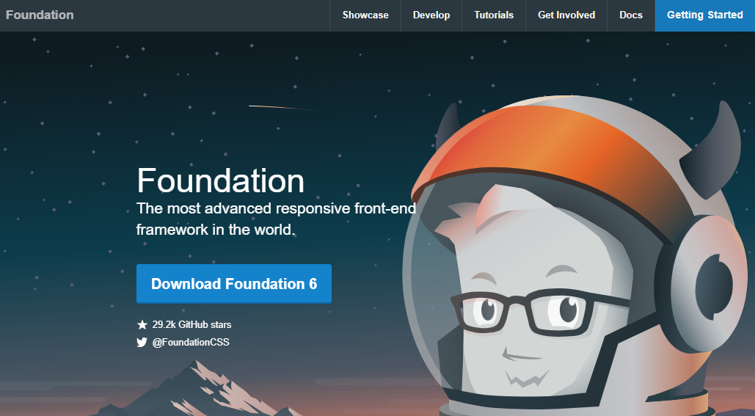

**Pure.css**

[Official Website](https://purecss.io/)

Pure.css is another library for building user interfaces. While it doesn't have as many features as Bootstrap, it is designed to be minimal in file size. Smaller file sizes improve loading times for web pages as there is less data to transfer from the web server. If your next project is focused on minimal loading time, this library is worth considering.

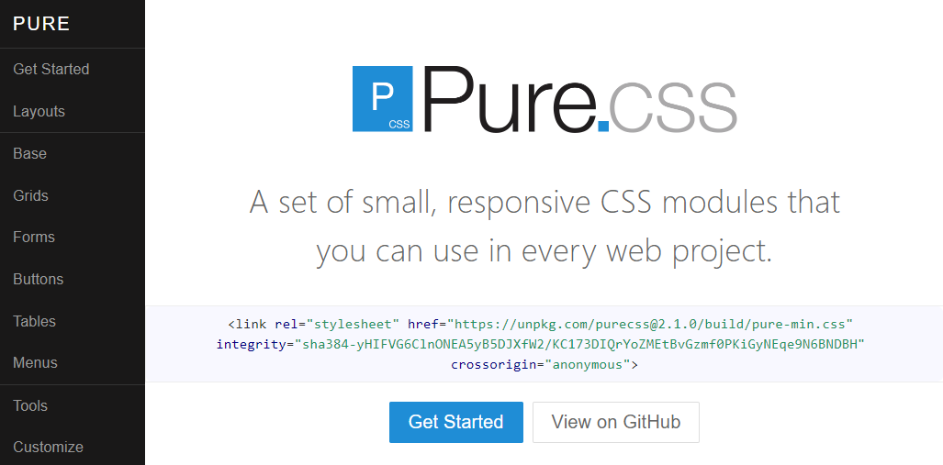

**Tailwind CSS**

[Official Website](https://tailwindcss.com/)

Tailwind CSS is a CSS framework that uses a utility-based approach for its CSS rules. This means that the framework provides many CSS classes with a single purpose. For example, the CSS class pt-6 sets the padding-top CSS property to 6 pixels. This means that you can be precise in applying styling to your HTML without writing CSS. The advantage to this is that it is more flexible for customizing your webpage's design using the framework. However, the disadvantage is that if multiple developers are working on a project, it could lead to inconsistent design if the team is not strict on its design rules.

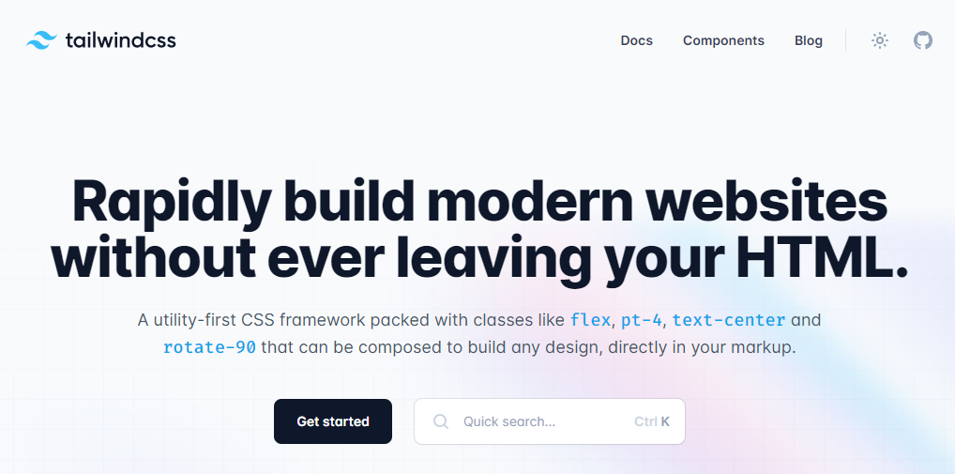

**UIKit**

[Official Website](https://getuikit.com/)

UIKit is a lightweight CSS framework featuring a small set of responsive components. Its simple design allows developers to easily customize the style rules and visuals.

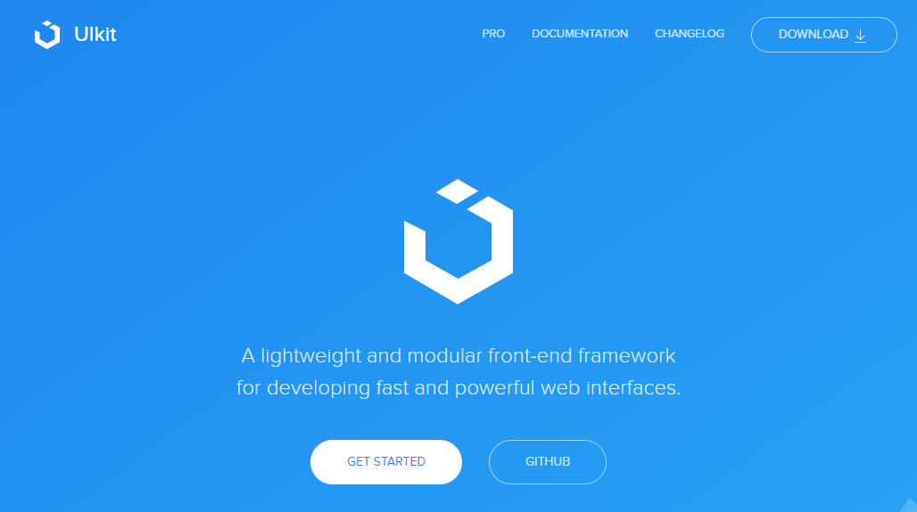

**MVP.css**

[Official Website](https://andybrewer.github.io/mvp/)

MVP.css is a small CSS library that automatically styles HTML elements without needing to apply CSS classes to them. The library aims to allow a developer to quickly prototype a user interface without worrying about the final design, while still being visually appealing. MVP comes from the technical term Minimal Viable Product, a product with sufficient features to demo to customers or other business stakeholders.

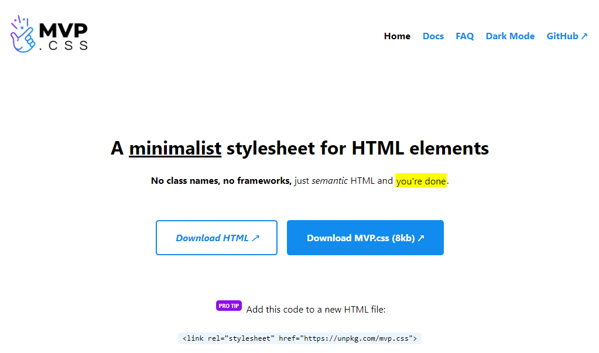

**Conclusion**

If you're curious to learn more about these frameworks, their websites feature set up guides, tutorials and documentation to get started. It is a good exercise to compare and contrast different libraries and frameworks to understand different workflows available to you as a developer.